**Ervia CCUS Project Information**

**Project Developer Website**

Ervia https://www.ervia.ie/who-we-are/carbon-capture-storage/

**Project Location**

Cork, Ireland

**Project Type**

Full-Chain CCS

**Project Description**

Ervia is investigating the potential for large-scale CCS in Ireland to capture the CO2 from a number of gas-fired CCGT power plants and heavy industrial emitters. The project is at an advanced feasibility study stage, examining the potential for CO2, captured from industries and power plants in Ireland to be transported for safe permanent storage (export, e.g. Norway, or indigenous storage). The depleted Kinsale Head Gas Field off the South West Coast of Irelands shows potential as a future CO2 store and the related infrastructure shows potential for reuse. Initial findings suggest that CCS may be technically and economically viable for Ireland and, over the next few years, Ervia will continue detailed feasibility studies into the technology. The project has been granted PCI status.

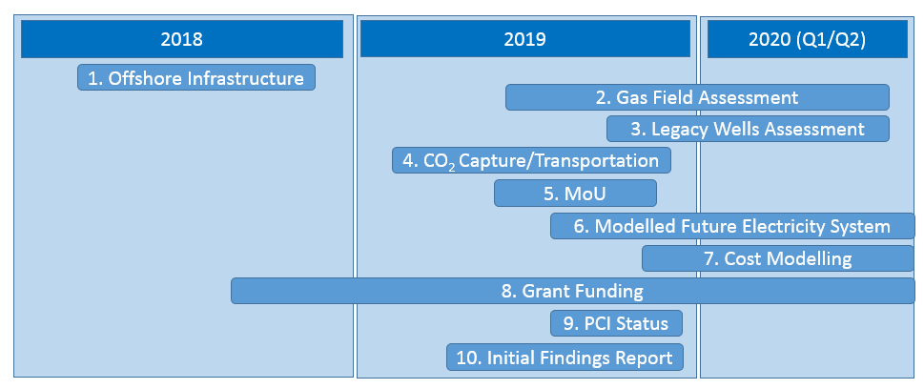**Assessing the potential for CCS: Work completed to date**

1. Assessed the condition of offshore infrastructure to determine suitability for future CO2 storage.
2. Assessed a portion of the Kinsale gas field for suitability to permanently store CO2.
3. Assessed condition of older wells at Kinsale gas field.
4. Assessed detailed technical aspects of capturing CO2 from power stations transporting for storage.
5. Signed Memorandum of Understanding (MoU) with Equinor, to jointly explore the potential to export CO2 from Ireland to the Northern Lights CO2 storage project in Norway.
6. Modelled future electricity system out to 2050 to determine need and cost/benefit of deploying CCS for power generation.
7. High level modelling of costs to develop and operate CCS on a gas-fired power station.
8. Made a number of grant applications for EU funding. Successful application to-date for funding to deploy a small test carbon capture unit at Irving Oil refinery in Cork.
9. Obtained PCI (Projects of Common Interest) status for Cork CCS assessment.
10. Produced Initial Findings Report for the Government Steering Group on CCS.

**Findings to-date:**

At the highest level, Ervia’s work to date has focused on answering the following three key questions:

*1. Is CCS technically doable for power generation and for the refinery in Cork?*

Work to-date indicates that CCS is technically doable. The ability to export CO2 for permanent storage simplifies the CCS infrastructure requirement for Ireland. Export of CO2 could be implemented ahead of indigenous CO2 storage and Kinsale could be implemented once subsea storage of CO2 is well established in Europe.

*2. Is CCS cost competitive vs alternatives?*

Ervia and other studies into the cost of CCS showed that it could be developed for power generation and heavy emitting industry with the export option for c. €100/tonne of CO2 abated. This compares favourably with alternatives.

*3. Will CCS be needed in Ireland?*

In order to assess whether CCS will be needed in Ireland, Ervia commissioned a report from Baringa focusing on the electricity market. Baringa’s results indicate that although it is possible to decarbonise electricity generation in the long term without CCS in Ireland, however doing so will cost significantly more than with CCS. Furthermore, Ervia engagement with heavy industry indicate a recognition that CCS will most likely be needed unless hydrogen is available at very large scale.

**Operational Status**

Concept/Detailed Feasibility Phase.

Currently at advanced feasibility stage.

Potential date to become operational by: 2028/2032

**CO2 Reduction Potential**

The Kinsale Head gas field is estimated to have c300MT of CO2 storage capacity.

If both CCGT’s in the Cork region, and the Oil Refinery were decarbonised using CCS, the annual CO2 emissions abated would be c.2MT p/a. If CCS is used within the Dublin region, for a single CCGT and Industry (waste incinerator), the emissions abated would be c. 1.5MT p/a).

**Project Financing**

Ervia has an annual capital expenditure across its gas transportation and water utility companies of approximately €750m. Project financing will ultimately be determined by the range and type of emitters implementing CCS in Ireland. Potential EU funding for capture technologies is available from the ETS innovation Fund. Potential Connecting Europe Facility funding for Projects of Common Interest (PCI) under the Ten-E Regulation is available for the cross border transportation of CO2. Ervia has had some initial CCUS H2020 funding success and further potential funding is available for CO2 Geological Storage from Horizon 2020/Horizon Europe. Ervia, as a potential CO2 transport and storage operator in Ireland, will work with other stakeholders along the CO2 value chain to maximise these funding opportunities. We will work closely with Government to identify potential support mechanisms that could assist in progressing the development of CCS in Ireland.